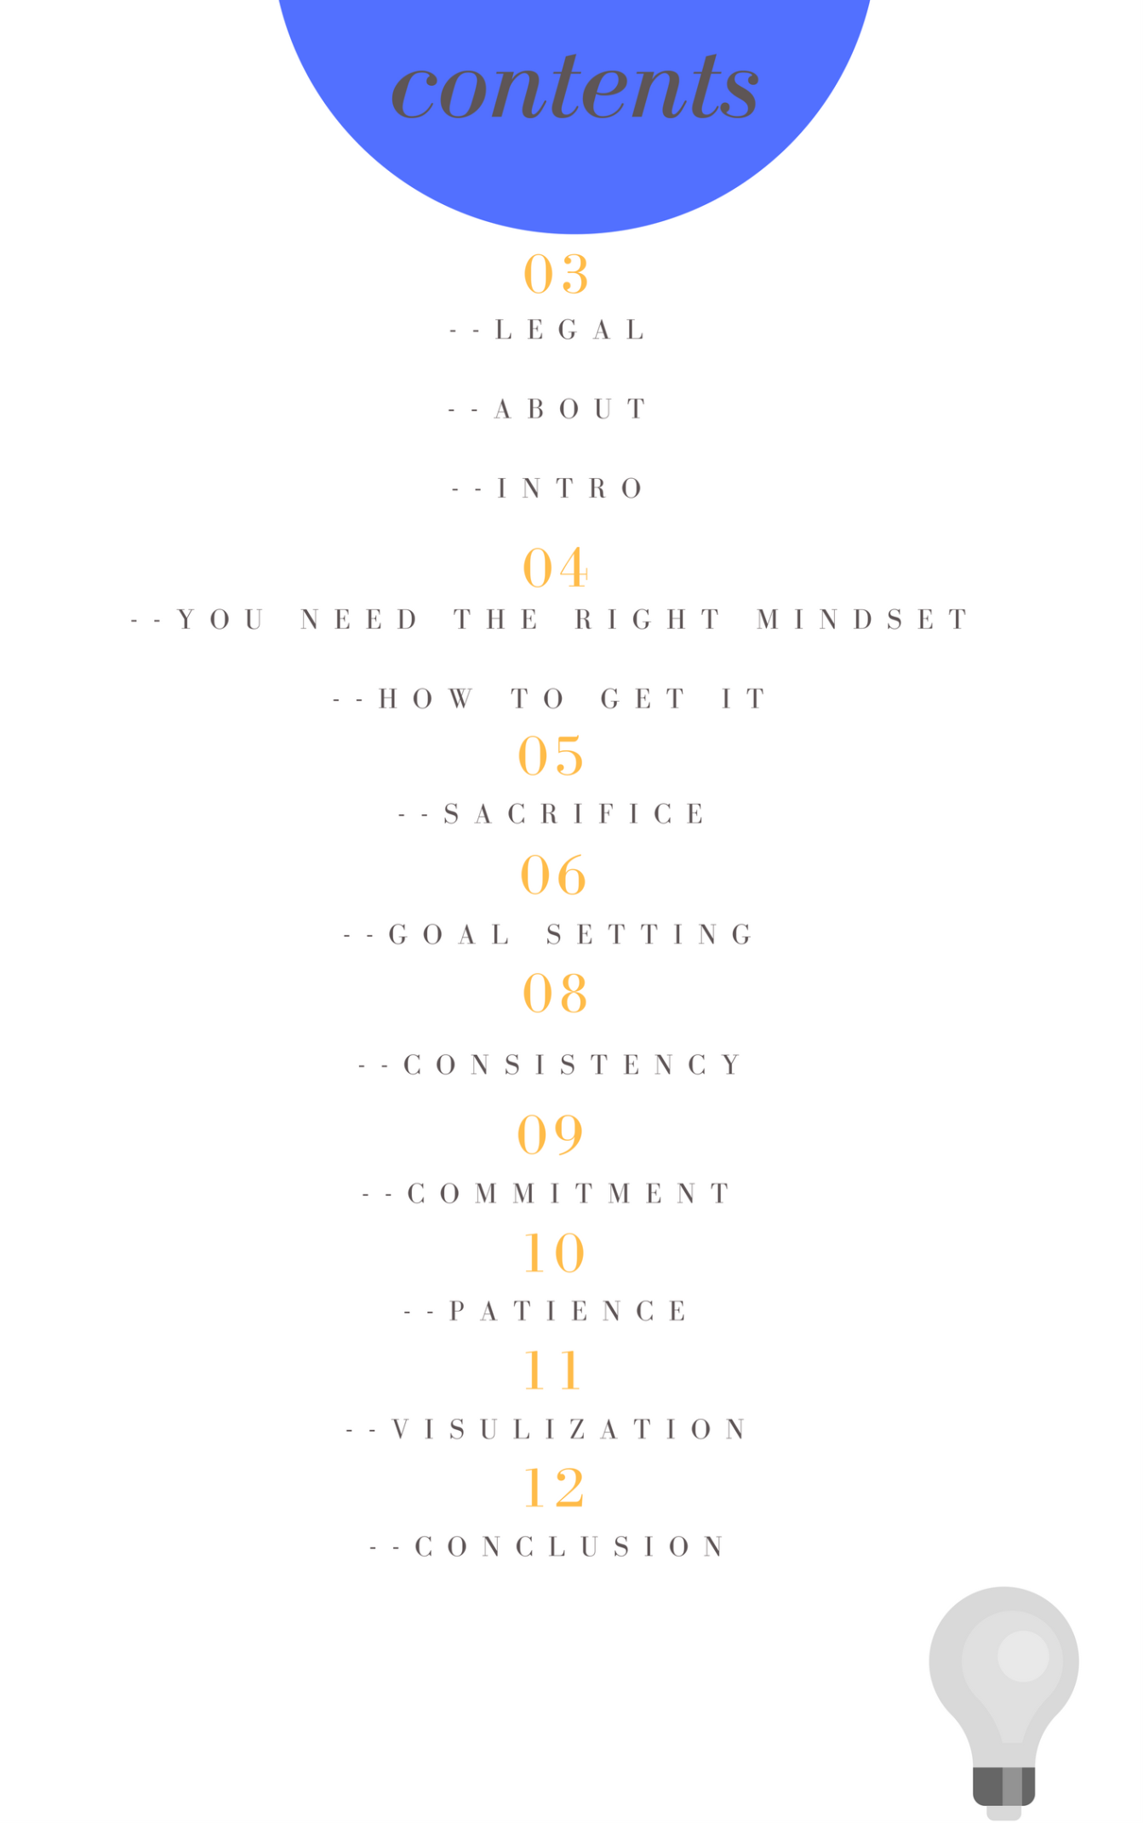
The legal stuff:
The author don´t take responsibility for his bad typing skills or spelling and grammar skills This guide is for your personal use and yours to read as much as you want. However, you are not allowed to share this guide with others. You are also not allowed to copy it and sell or give it away.
About the author?
John MKS, entrepreneur, (owner of various websites), is the author of this guide and he use the exact same principles taught in this book in ANY area of life, not only for making money online but for example to go and work out (6 times per week) even though he hates working out… It is the results he is after…
I am that guy by the way And now I want you to be completely honest with yourself as I promise to be real with you and say the truth and say it straight.
Are you ready for the truth?
Can you handle the truth?
You can´t handle the truth! (Jack Nicholson voice) Lol! Just kidding.
But first I want to show you (not to brag) some resent results from different passive income streams I got online:
Some resent passive income results:
Here are some recent passive income results I have got (all of them are for 1 day as you can see and also from 1 client) and the first one is almost $2,000 as you can see:

Below is from another passive income stream only a few days after:
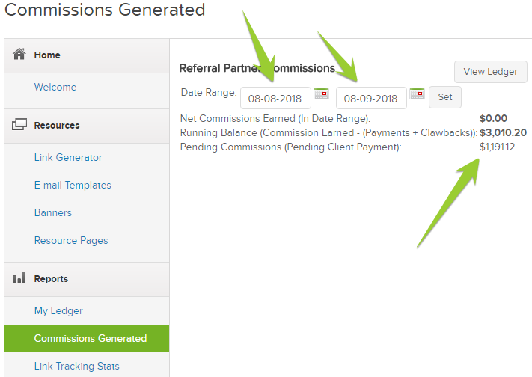
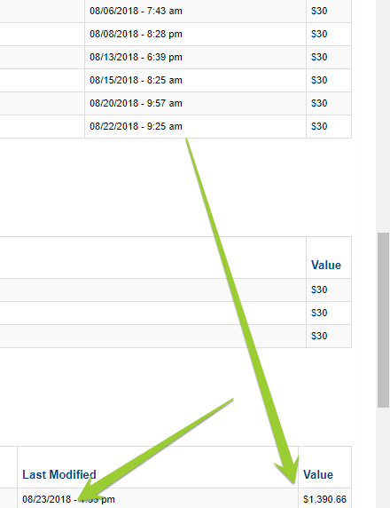
P.S.
I help people daily to achieve success online mainly through my e-mail list, where I got personal contact with a lot of people and even have started to work together with some of them. If you want to see what some of them have to say about me you can head over to one of my websites and read their stories at my about page.
Let´s start!
“My mama always used to tell me: If you can´t find something to live for, you best find something to die for” – Tupac Shakur
We are all going to die, every single one of us. EVERYONE. Everyone you love, all your family and your friends WILL die. It is not a question of if but when. Am sure you agree with me, right?
It can happen today, tomorrow or next year, one thing is for sure… It WILL happen. What will you leave behind to your loved ones?
What responsible do you have to make something out of your life and to be able to help your loved ones out?
your mother?
your Daughter?
your Son?
your brother?
your Sister?
your Father?
Anyone you love?
Don´t you feel that you actually not just want (or not want) but that you actually have to?
That it is your responsibility?
What can you leave behind to help them?
You might hate or love money, one thing is for sure, we all need it to live.
Are you going to leave depth or money to your loved ones when you die? Or are you just going to spend it on crap that won´t lead you anywhere?
Hint: Business minded smart people always invest in themselves. Both in books, courses, study, healthy food, etc… That is not a coincidence…)
Anyway, back to the point,
Nobody even have to die,
someone can get sick, get financial problems and so on… Can you help you loved one when that happens? Are you going to be the rock to hold when the storm passes by or simply sit there and wish you started a business last year? Or why you didn´t invested in crypto 1 year ago when you had some money to spend and Bitcoin costed only 10X less than now?
This guide will help you to know exactly how to “reset” your brain to become that rock, the best part is that you can actually use the principles taught here in ANY area of life, not only for becoming financially free. We will focus on the topic of creating a passive income online though, but am sure that you will understand that the power of what you learn can be used for ANYTHING…
IMPORTANT: Keep In Mind That ANYONE Can Do This! However, there is much more to it if you want to go deeper in the mind subject. I will leave links to books that I have read that have helped me develop this mindset)
Anyway: Let´s get started to see what it takes to (in this example) make big money online:
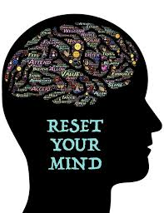
You NEED the right mindset!
Many people (have been the same in the past) think it will never work for them, that nothing works, that everything is a scam, and other insane thoughts that are absolutely not true. Sure, there are many scams out there but thinking everything is a scam is a BIG mistake.

You better believe this:
90% WILL be your mindset, it won´t happen until you got a number of things in place and the reality is that most people give up only after 2-4 months tops… Many times (ironically) just right before things starts to happen.
Only the worthy will reap the fruits…
You know the expression, right? Well, it is a tremendously great one
This is actually a good thing if you think about it because it means that only a person who deserves it will get it. Someone who won´t give up until he gets it, someone who is consistent EVERY day until the goals is reached for her, someone who wants it A LOT.
It actually also eliminates MOST of the competition right from the start.
Do you start to see why it is actually good?
You might think that it is hard because everyone try to make money online and there is no room for you but the truth is that there is a lot more room for you than you might think…
IF you have a “refuse to give up mindset”
Because most people simple aren´t prepare to put in the effort that it takes… The effort I mean here is the start, the learning period… Once you get it all figured out you won´t need to put in that much of effort, depending on what kind of money you want to make.
The “technical” part of how it works to make money online is no rocket science, sure it take a while to learn it but it is just like anything else and once you have learn it, then it will feel ridiculously easy.
Similar to riding a bike, once you learn it you will have the skill forever and be able to use it again and again.
Nobody is ever going to be fully learned though as the “online space” changes all the time.

How to get the right mindset (if you don´t already have it)
Am sure that not many people are born with a mindset like this, it is something that has to be taught.
How do you do then?
It is not complicated at all, you just decide (make a promise to yourself) and then take action… EVERY day until it becomes a habit… One thing at a time until you have changed everything you want to change.
How long does it take?
It is a well known saying that it takes around 21 days to create a new habit and that is probably true (due to own experience), however it will become more and more easy the more you do it but in the beginning you are going to have to force yourself to take daily action on your plan… Yes, that is the key of discipline.. You do what you are supposed to do whether you FEEL like it or not… You have to take it serious, its your life, its important, its your duty, its your advantage over 99% of people, its your secret, its your super power…
After (around) 21 days you are not going to experience it like you are forcing yourself and it WILL become A LOT more easy to do what you are suppose to do each and every time.
Continue another month the same way and then one more and it will be just as normal as brushing your teeth every night.
IMPORTANT TO MENTION HERE:
Habits grow stronger but be careful, they also grow weaker!
What I mean with this is that every time that you do something that is not comfortable for you (like working on your goals) you will train your mind to be stronger.
BUT… This works the other way around, every time you skip a day or like I would like to call it “bitch out” and tell yourself that “ahh, I skip today, I feel tired, I don´t feel like it today and so on…
EVERYTIME you do that you also train yourself to “bitch out” and it WILL be a lot easier to “bitch out” the next time…
Your habits get stronger the more you use them, similar to your muscles if you train them in a gym for example, but every time you break a habit (even if it is only 1 day) it will become weaker… and it will become easier to skip another day…
I really hope that you understand this because it is absolutely true.
Below are the only 6 simple (but yet hard for most people) keys you will ever need to accomplish ANY goals at all that you might have
NR 1: Sacrifice
I would like you to take 10-20 minutes to think through what you waste time on each and every day. Please don´t say that you don´t because we all do…
-Watching what your friends (and strangers) do on social media like Facebook, Instagram, etc
-Playing bullshit games like candy crush, clash of clans, clash of clash (or whatever their name is)
-Watching your favourite tv shows, late night fucking show etc… Waste of time! In Sweden we got a good old saying that tv means “dumburken”, in Swedish that means something like “stupid box” and that opinion got my 100% fully support Tel…lie…vision BIG TIME WASTE
-Even watching the news you can skip, they only show negative stuff (dangerous if you want to be happy)
- Playstation
- Xbox
Do any of those things help you in ANY way in your life??
Be honest with yourself and erase or “sacrifice” those “time wasting things from your life and make room for you to get THE life you want.
Trust me if you just change what you do with your time you can and WILL reach hights you didn´t think was possible in 1 year only.
You will be surprised how much time you all of a sudden will have if you quit all that bullshit and you WILL make A LOT of progress in reaching your goals this way.
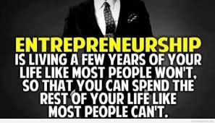
It will also give you a great feeling that you deserve it (what you are reaching for) and that will believe it or not both speed up the process and also make you sleep a lot easier and a lot better.
No excuses here, most of us got a lot more time than we think but still we hear the phrase “I don’t have time because I have school, I have work, I have this and I would do it if it only was this, waiting for the right time… There will NEVER be the right time! You have to start NOW, NOT tomorrow… Or well, yes tomorrow also ;)
ALL of that is bullshit excuses and you know it.
If you want something bad enough you will find time for it, if you don´t want it bad enough you will find an excuse.
Personally I had a 9-5 job when I started to learn and build my online business, right after work each day I went to the gym for 1 hour before I went home, took a shower and ate dinner… After all of that I sat down “working” on my business in front of the computer for 1-2 hours per evening before I had to go to bed to be able to work on my “normal” 9-5 job.
It was hard absolutely but now when I no longer have a 9-5 I can tell you with all my heart that it was worth it!

Nr 2: Goal setting
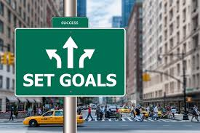
Am absolutely sure that if you get this part RIGHT it is really the only thing you need to success and to do it FAST.
You hear it all the time and maybe you have done it, however you have to do it the RIGHT way when you set your goals.
I will tell you exactly how to do this.
First let me tell you about a VERY interesting study that was published in the Forbes magazine about goal setting:
(Pay Close Attention To THIS, It is a MUST read)
The year 1979 there was a fascinating study made on the Harvard MBA program where graduate students were asked the question:
have you set clear, written goals for your future and made plans to accomplish them?
The result:
3% (only) had written goals and plans,
13% had goals but they had not write them down
and 84% had no goals at all.
Ten years later: The same group was interviewed again and the result?
It was absolutely mind blowing!
The 13% of the class who had goals (in their heads) was earning twice as much the amount of the 84% who had no goals.
Now listen to this!!: The 3% who had written goals were earning, on average, 10 TIMES as much as the other 97% of the class COMBINED!
COMBINED!
I can tell you ONE thing… When I saw this I really started to take my goals seriously.
I find this to be an extremely motivating example of why creating clear and measurable goals and WRITING them down is a key to success… In ANYTHING…
But, do NOT just write them down, NO!
I strongly suggest that you set your goals like this:
Do not just write them down and then go on with other things... That is not the proper way and will not help you much (as seen in the study).
I suggest you do like this instead to get the most benefits out of your written goals.
Do like this: Set a goal that is achiveable and WRITE IT DOWN, (it is important that it is a challenging goa that you almost cant believe in yourself but know deep inside that you should be able to reach if you follow the plan each day).
Then: you break down that goal in "small steps" that you have to do to achive the final goal. Write down EVERYTHING you need to do to achive the big goal of yours. Be as detailed as possible.
Then: put that list in order and put DEADLINES for each step.’
The you break them down as much so you have daily tasks planned for the whole month, at least for the whole week. You need to know what you should do each and every day by looking on your paper (with your goals written on) before you wake up, meaning you need to have that list ready before you go to sleep.
Now you have something to aim for...
Go ahead and WORK. Complete every step at the list in order and do it as fast as you can.
Make sure to have everything you have to do (your to-do list) written down before the day starts.
Do this for a longer period of time and you WILL get A LOT done and FAST, everyday adds up, and after a while all that “adding up” will get STRONG!
Nr 3: Consistency
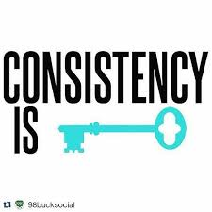
Ask any successful person about their key to success and you will find a common theme: Consistency
You have to stay consistent!
This is very close connected to goal setting and pretty much goes hand in hand with it.
Follow your “written down goal plan consistently over a longer period of time and you will also reach your BIG main goal in the fastest (and most efficient way) possible.
Consistency is also what will lead to you creating your new habits like we talked about further up in this guide.
Consistency is the key to your dreams and if you want to get there in the fastest way possible: Stay consistent.
This is a law of nature, if you do something consistent for a longer period of time only 1 thing can happen… You WILL get better at it!

Nr 4: Commitment
It is what it is, creating a passive income online is not something that you do (as a beginner) “overnight” but it also don´t have to take years.
Personally when I started I had the mindset right but the problem was that I had to learn it all from the start as I had no clue at all what to do.
It actually took me around 7 months before I made any money at all. However, it would have gone a lot faster if I knew what I know today. The truth is that I had no clue what I was doing for the first 4 months and I actually started all over again after 3 months…
After around 3 months of (almost) working daily on my new business it started to become frustrating and there was all the time a voice in my head that told me things like: “give up” “it is not worth it” “you will never make it” and so on…
The only thing that made me keep going was because I had the mindset on point. There was another (smaller and less loud but stronger) voice in my head that told me to keep going, refuse to give up!
Am so happy that I listened to that one instead.
Around 4 months after my “restart” one day when I watched my e-mail inbox BOOM! There it was! I had made money online from a website that I created and I had made that money while I was out on the streets with my mother and my brothers daughter.
I was so happy and I (of course) told my mother about it… She laughed when I told here that it was only $10 but she didn´t understand then…
I did though, I understood that if I could do it 1 time I could do it 10 times, 100times, 1000 times, 10 000 times, etc. That is how a passive online income works if you set it up right.
The day after I made another $10 and then things started to escalate pretty fast.
3 months after that first money made I actually made my first $2,000 + month and not many months after that I quit my 9-5 job and ALL the effort paid of in the end.
Nowadays I sometimes tell her other “fun happenings” related to online business, like the other week when I made a nice amount of $4,500 while I was sleeping, the money was made from a sale made from work I did 1 year ago, a total hours of maybe 1,5 hours… That is one of the great benefits… You can make money over and over again from work you did years ago…
You can achieve this also (and a lot more) if you just decide
Make a commitment to yourself for (at least) 1 year. Please don´t stress things, trust the prosses, take it step-by-step, in your own pace… Slower is better
Nothing will happen over a night, it WILL take some time so be prepared for that.
“We tend to overestimate what we can do in 1 day and completely underestimate what we can achieve in 1 year” – “Some very smart motherfucker”
This leads us to the next wildly important thing that you will need:
Nr 5: Patience
Just as the other “points” above this one also goes hand in hand with the others, you are going to have to be patient.
If you are not a patient person then it is time to test yourself and your limits. You do this the same way as you create a new habit (read further up).
I actually hate the question “are you a patient person?”
because I am sure that you can train yourself to be it, it is nothing you are born with.
Sure, some people might have a bit easier to be patient but it might have to do with the fact that they have been doing activities that “trains” them to be patient like fishing for example, or playing poker, etc.
And even if some people have some kind of “talent advantage” of being patient right from the start when they come out from their mothers wound that is absolutely NOT an exuce for you to NOT be…
It simply means that you have to work harder than that person.
DO IT!
“Consistency beats talent when talent doesn´t work”
– Some other smart motherfucker
Important to mention:
You can be good at something but to be great you are going to have to practice. If you want to be one of the greatest in the world you have to practice a lot and pretty much every day.
Think of it like this:
Every time that you practice on something, let´s take blogging as an example.
Let´s say that you start doing that today for 1 hour every day.
You are only going to get a little tiny portion better on doing it every day, only small improvements on how good it will be, how interesting, how long, how fast you finish it, etc…
The first day you struggle 4 hours to write 500 words and then do some “seo tweeking” by adding the keywords before you publish… Puh!
Now let´s say that you do this every day for 3 months, those tiny small improvements have now added up into a BIG one.
Now you can create beautiful, great and interestingly written, and you both write them and publish them in 30-60 minutes!
You don´t even have to think, you just finish it, do the seo tweeks (keywords, links, etc) publish and DONE.
-After 6 months your skills will be impressive to ANYONE and you are going to have A LOT of people visiting your blog (as you are using keywords).
-After 12 months you are thinking about when to quit your 9-5 (if you don´t already have) as you are now making more money (while you sleep!!) than you have ever made from any “traditional” job you have ever had.
-Another 12 months after that and you have probably changed your financial life completely and get jealous eyes on you from the “normal” the (haters) ones that aren´t able to commit 1 hour per day on changing their life that they aren´t even happy with)!
Another 12 months after that and your blog is well-known and successful with “fans” from all over the world and you
Was it fun to do this for 1 hour each day do you think?
Probably not every time, (at least not as fun as Facebook, Instagram, Snapchat, watching tv, watchin movies, candy crush, etc, etc)
Was it worth it?
Well you are now one of the best in the world on that skill and it can now make you very good money for the rest of your life with ease… So, yes, I really understand that you think it is worth it.
I really hope that you understand the above explanation as it is the key to REAL success.
In short, ANY new skill will require you to have: Patience
Nr 6: Visulaization
This might sound like a bunch of mambo jambo to you and I completely understand you, I used to think the exact same way until I came across the book “maximum Achievement” by Brian Tracy (will leave a link at the bottom of this ebook) and actually tried to visualize, or more correct expect success to happen.
The technique I used was that I wrote a goal on a piece of paper and then put it on the wall in front of my bed so it was the first thing that I would see when I woke up in the morning.
I wrote: “I believe that something great will happen to me today” and I read it and said it out loud to myself very night before I slept and every morning when I woke up. 10 times every morning for 3 months.
I also wrote another paper and put it on another wall, the wall in front of my computer so I could see it every time that I was in front of the computer.
On that one I wrote a specific and VERY hard to accomplish goal that I gave myself 3 months to achieve.
Guess what happened after only 2 months?
I absolutely crushed that goal (that at the time I set it seemed almost impossible to achieve in only 3 months).
Am completely convinced that those 2 papers on my 2 walls was the reason for it to happen, it was an amazing feeling and something I urge you to try… But really do it… Don´t half ass it.
That simple technique only worked wonders for me and I highly recommend you to try it out and I think you will be surprised on what you really can achieve.
If you want to go deeper into this subject go ahead and get the bestselling book (Maximum Achievement) also, will leave a link for you at the bottom of this review.

Conclusion
That´s it!
If you change yourself and your mind into this state, then there is NO WAY that you will not succeed to create a passive income for yourself online.
Nothing can stop you if you are in this mindset, you better believe that.
Or no sorry, you better KNOW that.
There are many different ways to do it and I will present different ways for you to do it, however, the way I did it was through creating a website and make money from it by selling things that was no even mine… No shipping, no handling, no boss… Yeah well, there are many more benefits to that.
However, the place I got started at was WA, but there are other places for you if you for some reason not like WA, for example, Affilorama is teaching pretty much the same way.
P.S. I recommend both, even though on WA you get help from me personally but you should of course pick the one you prefer, both are free to join so you could compare them if you want also.
If you want a great place to start (FREE to join) where you will get all the tools and 24/7 support to do all this then I highly recommend that you start at the same place I started as it will give you step-by-step videos on exactly how to set up your online business to start generating passive income online. Am still active there myself so you can be sure that I will welcome you personally
This link will take you there and also give you access to me as your mentor:
Click here to join WA for FREE
P.S. You will understand once you got your free account, just make sure to follow the steps layed out as it will give you so much more value.
See you inside!
Sincerely, John

Links to where you can get my recommended books to best price and fastest delivery:
Maximum Achievement – Brian Tracy
Rich Dad Poor Dad – Robert Kyosaki
Awaken the giant within – Tony Robins¨
P.S.
Keep in mind that only 1 of the books above can change your life, investing in yourself I something that books are made for, it is important that you read the right books though.

